**1. Please discuss an announcement in the Quality Engineering field that makes an impact on your future.**

QE space future - running tests headless on container based infrastructure like Docker cloud.

**2. Imagine your test needs to access an AWS service such as Dynamo DB. It will need access credentials to do that. Please draw a diagram with a description that explains one (or more) of the options for using AWS credentials in your tests. Select the method that you would recommend is used.**

AWS account root user – When first create an AWS account, it begins with a single sign-in identity that has complete access to all AWS services and resources in the account. This identity is called the AWS account root user and is accessed by signing in with the email address and password that you used to create the account.

IAM user – An IAM user is an identity within your AWS account that has specific custom permissions.

Below is the detailed diagram how it works

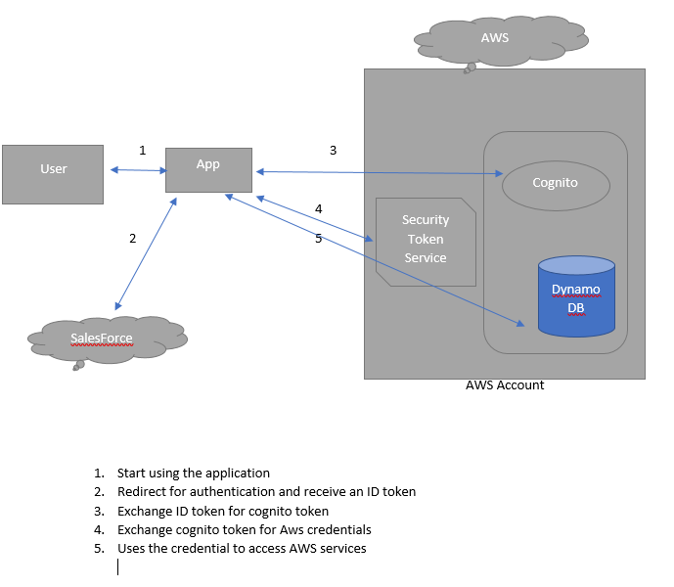

we normally encrypt it and chunk it in a s3 or in a server side script for the tests to pick up the credentials.

**3. Please explain who is the boss in an agile software development team.**

No boss, practically it is the Product Owner who takes the lead and Scrum Master is the overall facilitator who ensures everything is on track from dev team.